Delete equipment

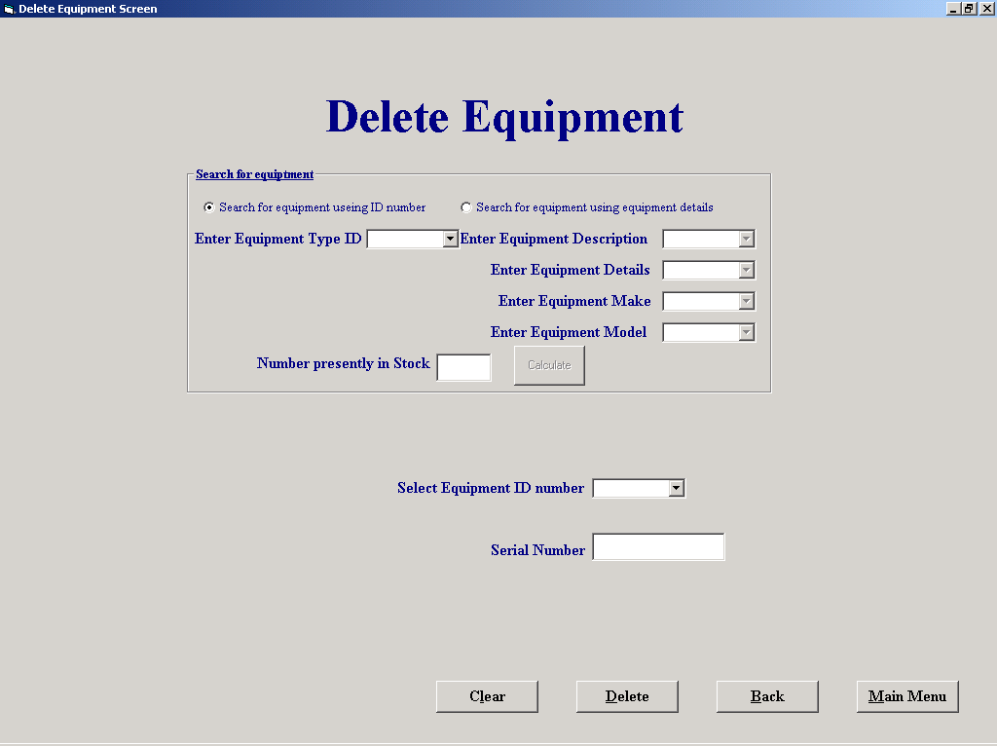

'Purpose This form allows the user to select a peice of equiptment for
' and mark its record for deletion. If the user knows the equipments
' ID number he can input it in a text box and then confirm it's
' serial number and then delete it (If the peice of equipment is
' out on hire then it should not be deleted)
' Alternatively you can search for the ID numbers of all stock
' by selecting either their Type ID number or working your way down
' a number of selection steps to search the a unique type. Each step
' You take reduces the scope of your search. When you have chosen the
' type you require you can calculate the number in stock and add the
' ID numbers to drop down list of a combo box
'Student David Hamilton
'StudentID Com2023
'Last Modified 15/3/02

'Variables used
'strMake String
'strModel String
'strDescription String
'strDetails String
'strAvailabilty String
'sqlDescription String
'strMess String
'sqlSN String
'sqlStatus String
'sqlEqptID String
'sqlCount String
'intID Integer
'intResponse Integer
'intNumber Integer
'intCount Integer

Option Explicit

'Checks if a valid "Equipment_ID" has been entered and if so it then checks
'If the equipment is on hire
Private Sub cboID_Click()
Dim intID, intResponse As Integer
Dim sqlSN, strMess, sqlStatus, strAvailabilty As String

intID = Val(cboID.Text)
sqlSN = "SELECT [S/N],Status FROM Equipment WHERE Equipment_ID = " & intID & " "

datSQL2.DatabaseName = "G:\EqpthireProject\EHS.mdb"
datSQL2.RecordSource = sqlSN
datSQL2.Refresh

On Error GoTo NoIDError
txtSN = datSQL2.Recordset.Fields("S/N")
strAvailabilty = datSQL2.Recordset.Fields("Status")
If strAvailability = "Out" Then
strMess = "This item of equipment is curently on hire and should not be Deleted"
intResponse = MsgBox(strMess, vbOKOnly, "Equipment on hire")
If intResponse = vbOK Then
txtSN = ""
cboID.Text = ""
cboID.SetFocus
End If
End If
Exit Sub

NoIDError:
If Err.Number = 3021 Then 'If an ID is entered that is not in the Table
If Len(txtSN) > 0 Then
strMess = "There is no matching ID"
intResponse = MsgBox(strMess, vbOKOnly, "Inncorect input")
If intResponse = vbOK Then
txtSN = ""
cboID.Text = ""
cboID.SetFocus
End If
End If
On Error GoTo 0
End If

'Resets screen to original settings

Private Sub cmdClear_Click()
cboEquipDescription.Text = ""
cboEquipDetails.Text = ""
cboEquipMake.Text = ""
cboEquipModel.Text = ""
cboTypeID.Text = ""
cboID.Text = ""
txtSN = ""
txtNoInStock = ""

End Sub

'Deletes the record curently shown
Private Sub cmdDelete_Click()
Dim intNumber As Integer

intResponse = MsgBox("Click OK to Delete all inputted Data", vbOKCancel, "Delete NOW")
If intResponse = 1 Then

datType.DatabaseName = "G:\EqpthireProject\EHS.mdb"
datType.RecordSource = "Equipment"
datType.Refresh

intNumber = Val(cboID.Text)
datType.Recordset.FindFirst " Equipment_ID = " & intNumber & ""

datType.Recordset.Edit
datType.Recordset("Deletion") = True
datType.Recordset.Update

cmdClear_Click
Else
cmdClear_Click
End If

Private Sub Command4_Click()
frmEquipmentFileProcessing
Unload Me
End Sub

Private Sub Command6_Click()
frmMainMenu.Show
Unload Me
End Sub

'When the form is loaded 2 combo boxes lists are loaded, cboTypeID contains
'a list of all the Equipment ID numbers, and the cboEquipDescription contains
'a list of Equipment descriptions (the first subset that a Type is devided into)
Private Sub Form_Load()
Dim sqlDescription As String

datType.DatabaseName = "G:\EqpthireProject\EHS.mdb"
datType.RecordSource = "Equipment Type"
datType.Refresh

While Not datType.Recordset.EOF
cboTypeID.AddItem datType.Recordset("Type_ID")
datType.Recordset.MoveNext
Wend

sqlDescription = "SELECT DISTINCT Description FROM [Equipment Type]"

datSQL1.DatabaseName = "G:\EqpthireProject\EHS.mdb"
datSQL1.RecordSource = sqlDescription
datSQL1.Refresh

While Not datSQL1.Recordset.EOF
cboEquipDescription.AddItem datSQL1.Recordset("Description")
datSQL1.Recordset.MoveNext
Wend
End Sub

Private Sub optEqptNum_Click()

cboTypeID.Enabled = True
cboEquipDescription.Enabled = False
cboEquipMake.Enabled = False
cboEquipModel.Enabled = False
cboEquipDetails.Enabled = False

End Sub

Private Sub optEquipName_Click()

cboTypeID.Enabled = False
cboEquipDescription.Enabled = True
cboEquipMake.Enabled = True
cboEquipModel.Enabled = True
cboEquipDetails.Enabled = True

End Sub

Private Sub cboTypeID_Click()
cmdNewItem.Enabled = True
End Sub

'calculate the number in stock and add the ID numbers to drop down list of
'a combo box
Private Sub cmdNewItem_Click()
Dim sqlCount As String
Dim intID As Integer
Dim intCount As Integer
Dim SQLEqptID As String

intID = Val(cboTypeID)
cboID.Clear

sqlCount = "SELECT Count(*)AS IDCount FROM Equipment WHERE Type_ID= " & intID & " AND Status = 'Available' AND Deletion = False ;"
SQLEqptID = "SELECT Equipment_ID FROM Equipment WHERE Type_ID= " & intID & " AND Status = 'Available' AND Deletion = False;"

datSQL1.DatabaseName = "G:\EqpthireProject\EHS.mdb"
datSQL1.RecordSource = sqlCount
datSQL1.Refresh

datSQL2.DatabaseName = "G:\EqpthireProject\EHS.mdb"
datSQL2.RecordSource = SQLEqptID
datSQL2.Refresh

intCount = datSQL1.Recordset.Fields("IDCount")
txtNoInStock.Text = Str(intCount)

While Not datSQL2.Recordset.EOF
cboID.AddItem datSQL2.Recordset("Equipment_ID")
datSQL2.Recordset.MoveNext
Wend

cboID.Enabled = True
End Sub

'This section is used to fill the Equipment Details drop down
'List with All the unique details of equiptment where the
'Description match those already chosen

Private Sub cboEquipDescription_Click()
Dim sqlDescription, strDescription As String

cboEquipDetails.Clear
cboEquipDetails.AddItem ("All")

strDescription = cboEquipDescription.Text
sqlDescription = "SELECT DISTINCT Details FROM [Equipment Type] WHERE Description = '" & strDescription & "'"

datSQL1.DatabaseName = "G:\EqpthireProject\EHS.mdb"
datSQL1.RecordSource = sqlDescription
datSQL1.Refresh

While Not datSQL1.Recordset.EOF
cboEquipDetails.AddItem datSQL1.Recordset("Details")
datSQL1.Recordset.MoveNext
Wend

End Sub

'This section is used to fill the Equipment Make drop down
'List with any make of equiptment where the Description
'and details match those already chosen

Private Sub cboEquipDetails_Click()

Dim sqlDetails, sqlMake, strDetails, sqlDescriptionAll As String

cboEquipMake.Clear
cboEquipMake.AddItem ("All")

strDescription = cboEquipDescription.Text
strDetails = cboEquipDetails.Text

If cboEquipDetails.Text = "All" Then
sqlDescription = "SELECT DISTINCT Make FROM [Equipment Type] WHERE Description = '" & strDescription & "'"
Else
sqlDescription = "SELECT DISTINCT Make FROM [Equipment Type] WHERE Details = '" & strDetails & "' AND Description = '" & strDescription & "'"
End If

datSQL1.DatabaseName = "G:\EqpthireProject\EHS.mdb"
datSQL1.RecordSource = sqlDescription
datSQL1.Refresh

While Not datSQL1.Recordset.EOF
cboEquipMake.AddItem datSQL1.Recordset("Make")
datSQL1.Recordset.MoveNext
Wend

'Using the infromation stored in the text part of the
'Equipment description,details,make and model comboboxes
'the unique Type ID can be queried from the equipment
'table this is then stored in the equipment number combo box
Private Sub cboEquipModel_Click()
Dim sqlDescription, strDescription, strModel, strMake, strDetails As String

cmdNewItem.Enabled = True

strDetails = cboEquipDetails.Text
strModel = cboEquipModel.Text
strMake = cboEquipMake.Text
strDescription = cboEquipDescription.Text

If strMake = "All" And strDetails = "All" Then
sqlDescription = "SELECT Type_ID FROM [Equipment Type] WHERE Model = '" & strModel & "' AND Description = '" & strDescription & "'"

ElseIf strMake = "All" Then
sqlDescription = "SELECT Type_ID FROM [Equipment Type] WHERE Model = '" & strModel & "' AND Details = '" & strDetails & "' AND Description = '" & strDescription & "'"

ElseIf strDetails = "All" Then
sqlDescription = "SELECT Type_ID FROM [Equipment Type] WHERE Model = '" & strModel & "' AND Make = '" & strMake & "' And Description = '" & strDescription & "'"

Else
sqlDescription = "SELECT Type_ID FROM [Equipment Type] WHERE Model = '" & strModel & "' AND Make = '" & strMake & "' And Description = '" & strDescription & "' AND Details = '" & strDetails & "'"
End If
datSQL1.DatabaseName = "G:\EqpthireProject\EHS.mdb"
datSQL1.RecordSource = sqlDescription
datSQL1.Refresh

While Not datSQL1.Recordset.EOF
cboTypeID.Text = datSQL1.Recordset("Type_ID")
datSQL1.Recordset.MoveNext
Wend
End Sub

'This section is used to fill the Equipment Make drop down
'List with any Model of equiptment where the Description
'details and make match those already chosen

Private Sub cboEquipMake_Click()
Dim strDescription, sqlDescription, strMake, strDetails As String

cboEquipModel.Clear
strDetails = cboEquipDetails.Text
strDescription = cboEquipDescription.Text
strMake = cboEquipMake.Text

If cboEquipMake.Text = "All" And cboEquipDetails = "All" Then
sqlDescription = "SELECT Model FROM [Equipment Type] WHERE Description = '" & strDescription & "'"

ElseIf cboEquipMake.Text = "All" Then
sqlDescription = "SELECT Model FROM [Equipment Type] WHERE Description = '" & strDescription & "' AND Details = '" & strDetails & "'"

ElseIf cboEquipDetails.Text = "All" Then
sqlDescription = "SELECT Model FROM [Equipment Type] WHERE Description = '" & strDescription & "' AND Make = '" & strMake & "'"

Else
sqlDescription = "SELECT Model FROM [Equipment Type] WHERE Make = '" & strMake & "' AND Description = '" & strDescription & "' AND Details = '" & strDetails & "'"

End If

datSQL1.DatabaseName = "G:\EqpthireProject\EHS.mdb"
datSQL1.RecordSource = sqlDescription
datSQL1.Refresh

While Not datSQL1.Recordset.EOF
cboEquipModel.AddItem datSQL1.Recordset("Model")
datSQL1.Recordset.MoveNext
Wend
End Sub

